
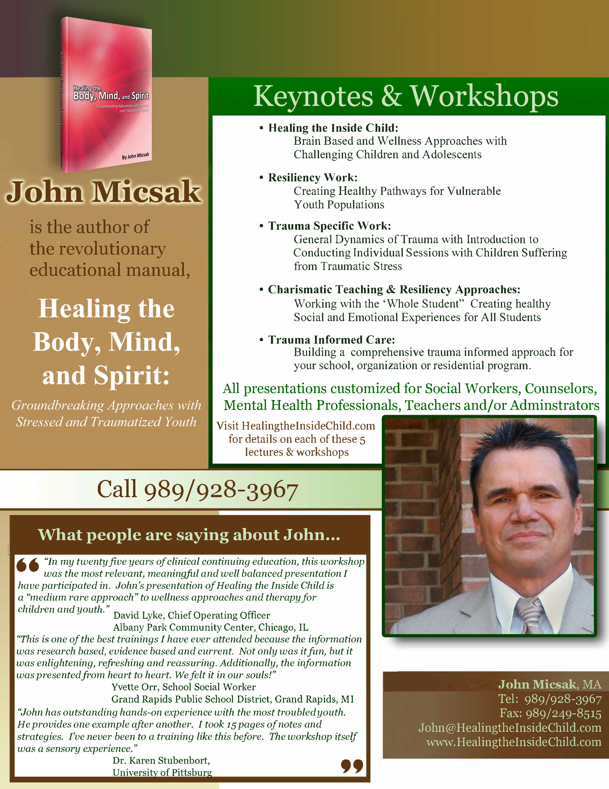
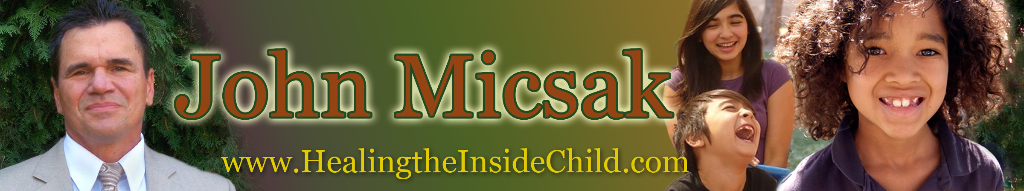

Do you know how to enhance brain chemistry without medication?
Are you under-serving children that do not have the resiliency
to bounce back from abuse, neglect and multiple traumas?
How differently would you feel going to work each day if you knew
your approaches were healing rather than punitive?
Do you feel powerless to change the high rate of failure with challenging youth?

You are not powerless. It is within you right now to begin to implement positive, dynamic and meaningful interventions for special needs youth. Budget cuts notwithstanding, you can access information and initiate changes now to use the trauma informed, resiliency model options for challenging children. No matter what circumstances you are facing.
Healing the Inside Child
Brain-based & Wellness Approaches with Challenging Children and Adolescents

Acknowledging and utilizing the latest brain research unequivocally proves that brain chemistry is influenced dramatically by restorative relational experiences and sensory adaptable environments. Clinicians and teachers will identify healing solutions informed by revolutionary breakthroughs in the three regions of the brain as defined by the thinking brain (cortex) responsible for abstract reasoning; the emotional brain (limbic) responsible for affect regulation, empathy, affiliation and tolerance; and the survival brain (brain stem or reptilian) responsible for fight or flight, heart and other body regulation functions.

You’ll witness the transformative effects of techniques filmed and played of case reviews with clinical applications. With non-violent and violent crimes of youth rising at staggering levels, this pivotal point in time demands a high quality multi-theoretical training approach that combines neuro-relationship science with positive youth psychology and resiliency research. John Micsak draws on social, emotional and relational factors that impact how adults work with children and adolescents. There is no need for these children to be left behind or held hostage by childhood experiences over which they had no control. We who interface with them have the power to make a dramatic difference in the outcome of their lives.

In Healing the Inside Child, you’ll discover:

- Cutting edge brain research & breakthroughs in neurophysiology (body/mind)related to adverse childhood experiences and developmental trauma disorder
- Options on enhancing brain chemistry without medication
- An understanding of adverse child events and the impact they have on the body, mind and spirit
- What professionals must know before trying any techniques and strategies for behavioral change
- How to set up healing environments for home, school and residential facilities
- How to apply over 21 powerful strategies including titration/pendulation, bids and windows and micro-connecting
- Self exploration activities to develop our brain and body systems
- Practices that help youth with neurological deficits “catch up”
- How to provide extraordinary care-giving through conscious relationship building

John Micsak knows firsthand from 33+ years as a passionate clinician and frontliner with vulnerable youth with traumatic and delinquent histories in some of the most repressive environments imaginable. Founder of the National Institute of Healing & Wellness, John has offered over 40 accredited subjects and has synthesized research from resiliency work, trauma informed care and body/mind science into a cutting edge approach in healing stressed and traumatized youth.

Are you too tired after work to read about the current research effecting traumatized and vulnerable children?
Are you ready and open to learning innovative methodology influenced by neurophysiology?

Brain plasticity or neuroplasticity is the lifelong ability of the brain to reorganize neural pathways based on new experiences. What happens to the brain during and after mild to severe trauma? What impact do people and the environment have on vulnerable children following trauma? There is much more that we can do than medicate victims. Healing is not based on behavior change, but on positive relationships, a positive environment and repetition of both.
Trauma Specific Work
General Dynamics of Trauma with Introduction
to Conducting Individual sessions with Children suffering from Traumatic Stress
John Micsak reveals the facts and information that parents and professionals need to know to be of help to traumatized children. Identifying more than 25 Adverse Child Events indicated in developmental trauma disorder, you’ll learn the difference between acute stress and traumatic stress and how universal the “stress spectrum” is in all of our lives.

Clinicians and other human service professionals will identify healing solutions informed by revolutionary breakthroughs in the three regions of the brain as defined by the thinking brain (cortex) responsible for abstract reasoning; the emotional brain (limbic) responsible for affect regulation, empathy, affiliation and tolerance; and the survival brain (brain stem or reptilian) responsible for fight or flight, heart and other body regulation functions

Learn the basic keys on how to effectively process the trauma narrative- the stories children need to share to move from victimization to victory. John will also introduce more advanced modalities such as somatic processing, sensory integration, and energy psychology and contrast them with traditional approaches. You will also learn how to implement trauma informed strategies in group settings such as residential treatment programs and school systems.

“John Micsak’s concepts were put into practice at an individual level, as well as the group, allowing our treatment staff to significantly reduce the acting out behaviors on our specific site. The growth that took place with our students was largely due to our dedicated treatment staff and the implementation of the strategies taught by John.”
Steve Kress, Juvenile Probation Officer, Lapeer County, MI
In Trauma Specific Work, you’ll discover:

- The definition of Type I and Type II trauma
- The definition of Complex PTSD and its implications
- Risk factors for PTSD/neurological considerations
- The 8 themes to identify with children of trauma
- The appropriate intervention needs of the traumatized child/adolescent
- What parents and caregivers need to know
- How effective therapists conduct individual sessions
- Strategies in debriefing after traumatic events
- Key concepts to build a trauma informed program
- Introduction to advanced modalities
John Micsak knows firsthand from 33+ years as a passionate clinician and frontliner with vulnerable, traumatic and delinquent histories in some of the most repressive environments imaginable. Founder of the National Institute of Healing & Wellness, John has offered over 40 accredited subjects and has synthesized research from resiliency work, trauma informed care and body/mind science into a cutting edge approach in healing stressed and traumatized youth.

Are you joining others in misreading disturbing personality traits in children?
Are you wondering why traditional methods are not effective with the third millennium youth culture?
Are you frustrated with ineffective institutional protocol with a blind eye to science?
Do you understand how the pre-frontal cortex affects self control in teens?
Do you want to know what’s working in today’s most innovative settings with challenging children?

It’s time to look beyond the obvious symptoms, stop labeling kids as sociopathic and ADHD (for instance) and start implementing what we’ve learned from neurophysiology (body and mind research). We now have the evidence of how to create new neuro pathways to help heal a child while we seek to eliminate toxic relationships and toxic thinking. Children in trouble shouldn’t be held hostage by our ignorance. Medication may save or stabilize a life but it takes away from our responsibility to protect and to provide holistic healing for children that have experienced adverse life events.
Resiliency Work
Creating Healthy Pathways for Vulnerable Youth Populations

John Micsak reveals in this presentation what our “Microwave Society” has created in our desire to “deal with” children and adolescents acting out. Acknowledging and utilizing the latest brain research unequivocally proves that brain chemistry and brain structure is influenced dramatically by restorative relational experiences and sensory adaptable environments. The brain can repair itself – even rewire itself in the right circumstances. Clinicians and teachers will identify healing solutions informed by revolutionary breakthroughs in the three regions of the brain as defined by the thinking brain (cortex) responsible for abstract reasoning; the emotional brain (limbic) responsible for affect regulation, empathy, affiliation and tolerance; and the survival brain (brain stem or reptilian) responsible for fight or flight, heart and other body regulation functions.

John’s presentation covers resiliency and strength based approaches vs. medical/disease model approaches. He includes self esteem, resiliency and NIRW research on the basic bio-social needs of all children and adolescents and how clinicians, teachers and families can meet those needs. You’ll appreciate a case review with clinical application of techniques and strategies while viewing Broken Circle, an award winning documentary on the plight of an young boy caught in the foster care/adoption system and Jonathon , the plight of an adoptive child with a history of trauma and with fetal alcohol spectrum disorder.

In Resiliency Work, you’ll discover:

- An overview of the “Microwave Society” and the “Second Family Phenomenon”
- The common characteristics of the millennium youth culture and how we misread them
- Impact of adverse childhood events: The Stress Response system
- How children in out of home placements have historically been de-moralized
- How to meet the 5 critical needs for emotional and psychological wellness
- The 10 fundamentals of becoming a charismatic (protective) adult
- The difference between risky vs. charismatic (protective) adults
- Specific group activity demonstrating how to build skill sets in tuning in and listening to youth
- 21 strength based and resiliency strategies
- Characteristics of the Relationship Factor vs. Behavior Blueprints
- A self-exploration exercise mapping the blueprints of your unconscious

John Micsak knows firsthand from 33+ years as a passionate clinician and frontliner in working with youth that have had traumatic and delinquent histories in some of the most repressive environments imaginable. Founder of the National Institute of Healing & Wellness, John has offered over 40 accredited subjects and has synthesized research from resiliency work, trauma informed care and body/mind science into a cutting edge approach in healing stressed and traumatized youth.

JOHN MICSAK
PRE-PROGRAM QUESTIONNAIRE
This document is in Microsoft Word, so you may complete it on-line and return to John@HealingtheInsideChild.com
Select highlighted area next to question and begin typing
EVENT TITLE:
ORGANIZATION:
EVENT DATE:
EVENT TIME:

The Program

- What is the conference/meeting theme?

- What is the specific purpose of this meeting? (Annual event, awards banquet, training session)

- What are your specific objectives for this event?
A.
B.
C.

- What takes place immediately before & after John’s presentation (lunch, another speaker, etc.)?
Before:
After:

- Who will introduce John? Name:
Title:

- Exactly what time would you like for John to be in the meeting room prior to the speaking time?

- Time of presentation. Start: End:

The Program (continued)
- Are you planning to audio and/or video tape the presentation?
Audio?
Video?

What will the recordings be used for?

Please remember, you must receive written permission from us to do so!

Are you requesting permission now? Yes No
Have you already requested permission? Yes No
Explain:
- Which speakers have you used in the past for a similar event?

- With your permission, we would like two contact persons John can personally speak with for more information.

Name
Title:
Phone (H):
Phone (W):
Phone (Cell):

Name
Title:
Phone (H):
Phone (W):
Phone (Cell):

- Is the event private or open to the public

Audience Information

1. Number of attendees?

- Who will be attending this event -social workers, counselors, mental health professionals, teachers and/or administrators?

3. What are the names and titles of your directors or executives who will be at the meeting?
A.
B.
C.

4. Is there anything John should know about the audience before addressing them?

General Background Information

1. What is the purpose/mission of your organization?

2. Is there a shared concern by the audience and, if so, what is it?

3. What is the greatest challenge they are currently facing?

4. What are the most significant events that have occurred in your organization or group during the past year?

5. What have the people in my audience seen, experienced, or contributed in the past year or quarter, that had a
positive impact on the organization’s current goals and/or mission?

6. What is one thing your team needs to master or be on top of and/or understand for your organization's current
goals and/or mission?

Additional Information

Contact person at the event?
Phones: (W)
(C)
(H)

If there is an emergency person while you are traveling, who should be contacted?
Name:
Phones: (W)
(C)
(H)

Emergency Back-up:

Event location:

Phone:
Fax:
Event Room:
Distance from Hotel:

Audio/visual requirements:

- One LCD projector w/remote for power point
- Adequate speaker system
- One projector screen
- One A/V table
- One resource table
- One lavaliere microphone
- Dry erase board or flip chart w/ markers

Have these arrangements been made? Yes No

Hotel where John will be staying (if different from above).
Room should be a suite, or a junior suite, charged to the master account for room and tax.

Phone:
Fax:
Distance from airport:
Hotel Confirmation #l

Person picking up and returning John to airport (if required):
Company:
Name:
Phone: Cell:
Confirmation # for ground transportation:
Will driver meet John at the baggage claim? Yes No
Or curbside? Yes No

Driver needs to have a sign that says “MICSAK”

Extended Learning Materials

John has extended learning materials that he would like to make available for your audience after his presentation. He is happy be available for photo opportunities with buyers or any in the audience following his appearance.

May he be permitted to sell products? Yes No
If yes, we can arrange this in two ways. Which do you prefer?
A. Group purchase in advance for each attendee at discount price.
B. Materials made available outside meeting room after presentation.

If A, an invoice would be sent to you. Only additional charges would be shipping.
If B, please make sure that:
- Nothing will be happening after presentation for at least 15 minutes
- A six-foot skirted table will be available either at the back of the room or outside the meeting room
- Someone from your group will be available to assist John at the product table
Location to ship product, if applicable:

ATTN:

Phone:
Cell:
Fax:
Your email address:

Your website address:

End of document “John Micsak Pre-Program Questionnaire”

John Micsak’s
Introduction

My job is to introduce John Micsak.

Typically, introductions review a speaker’s resume and experience. However, were I to do that it would just slow us down in getting to the good stuff and you’d forget it all in ten seconds.

Besides, who cares that our speaker …
- was the 2009 Consultant of the Year from the National Institute of Trauma and Loss in Children;
- has over 33 years of front line experience with abuse and neglect and delinquent youth populations;
- and has been featured in Psychology Today for his ground breaking work in the healing of at risk-children?

Besides, if you really want to know the details on John you can call his mother… or visit his website at healingtheinsidechild.com

Instead, I’ll just tell you we’re about to spend some time with a man who has revolutionized our system of care for stressed and traumatized youth. He pulls no punches and delivers his message with passion and power.

Ladies and gentlemen, please help me welcome our guest… an experienced front liner, clinical educator, author and the founder of the National Institute for Resiliency and Wellness.

Mr. John Micsak

Audio Visual Requirements

Our room set-up and A/V requests enhance John Micsak’s program for the ultimate benefit of the audience. Please discuss any changes in the room and AV requests with our office beforehand. We do not want to be the cause for additional work, but sometimes just a little extra effort can mean a great deal to the outcome. An ineffective room set-up can sabotage the best speech.

    - One LCD projector w/remote for power point
    - Adequate speaker system
    - One projector screen
    - One A/V table
    - One resource table
    - One lavaliere microphone
    - Dry erase board or flip chart w/ markers

Evaluation for John Micsak

Program Date: ______________________________________________________________
Organization: ______________________________________________________________
Topic: ____________________________________________________________________

Please take a moment to answer the questions below. Thank you for continually helping us improve the value of the programs offered by John Micsak. Please give to attendant following the presentation. Thank you!

Please rate the program:
Yes Somewhat No
- John was effective in communicating information   
- He made a positive impact.   
- Visual aids were appropriately used to facilitate an
understanding of the topic   
- I learned new skills, gained new insight and understanding.   
- Offering books and tapes was satisfactory.   
- The style, delivery and humor was satisfactory.   
- The topic was relevant and timely.   
- John was well organized and easy to understand.   
- Handouts were satisfactory.   
- Probability of returning for another appearance.   
Excellent Adequate Poor
Video/promo tape previewing speaker was…..   
Credibility and believability of speaker………….   
Ease of working with speaker………………………   

Taking all items into consideration, I would rate this program as: (please circle one)
Excellent Above average Good Fair Poor

The most useful information was: ____________________________________________________________________

Suggestions for improvement: _______________________________________________________________________

____YES! I’m interested in hiring John to speak or train the members of my organization.

Please contact me at: Tel:( ) __________________________ E-mail_______________________________

A major source of John’s business is through referrals. What company, business organization, or association do you know of that would benefit from his services? Thank you!

Referral Name__________________________ Tel: (__)_____________ E-mail______________________

Referral Name__________________________ Tel: (__)_____________ E-mail______________________

Referral Name__________________________ Tel: (__)_____________ E-mail______________________

Your comments and testimonials are welcomed!

